At first we will add a user to our Proposal Manager

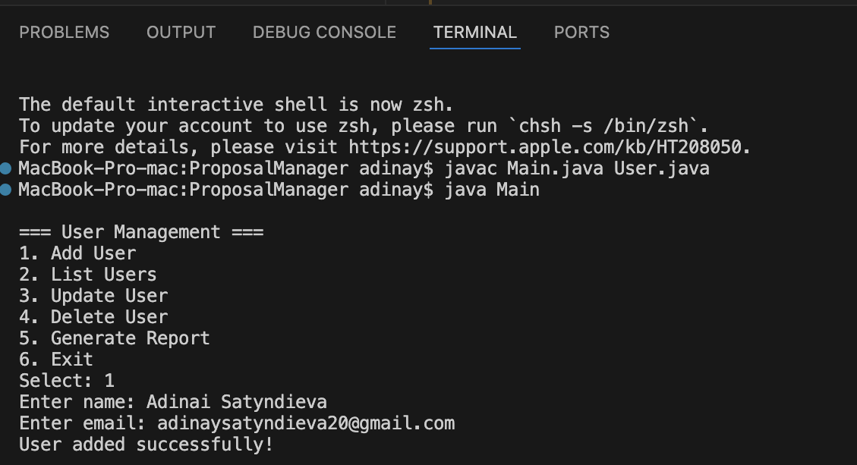

Let’s try to List a user that we added

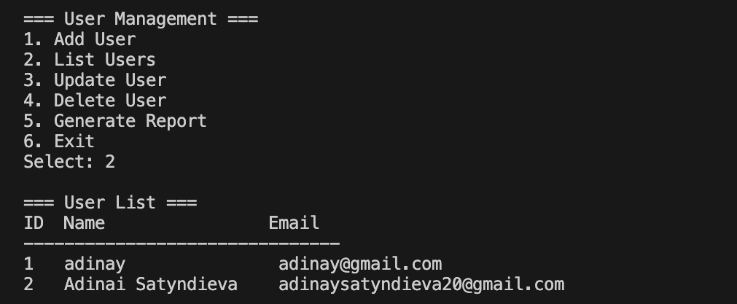

Now we can update a user

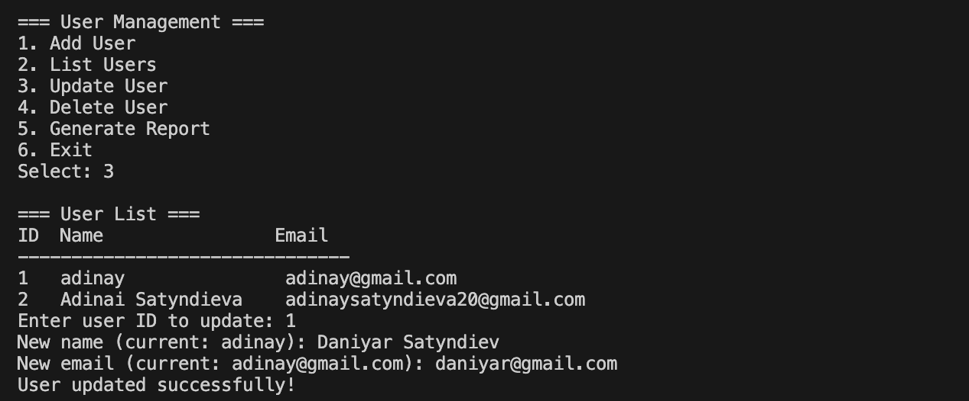

Then we can delete a user

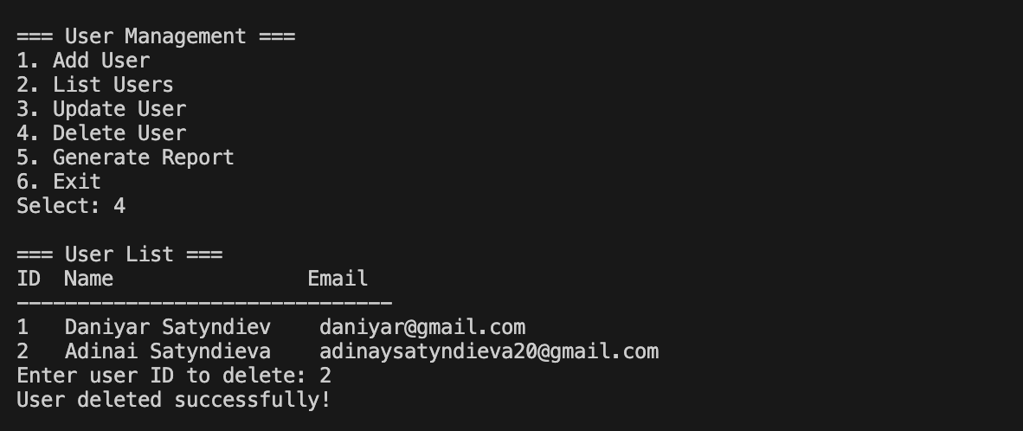

The we can generate a report about the changes that were made recently

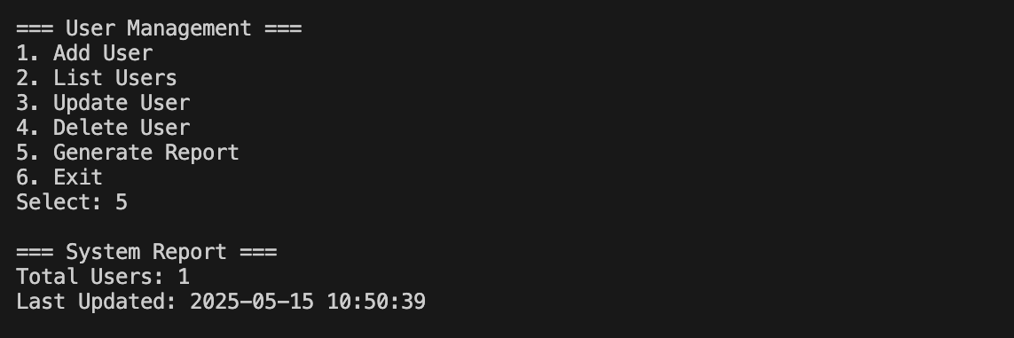

Now let’s just exit and come back to where we were

